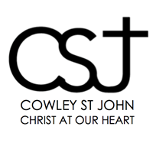

Alive in Christ
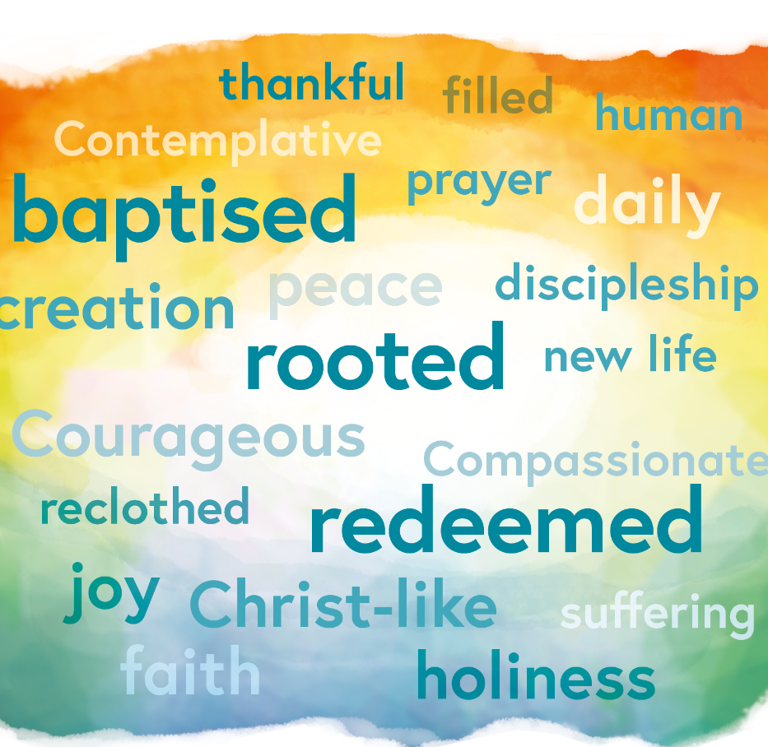

LENT PROGRAMME 2019
“Above all, clothe yourselves with love, which binds everything together in perfect harmony. And let the peace of Christ rule in your hearts, to which indeed you were called in the one body. And be thankful. Let the word of Christ well in you richly”
Colossians 3.14

MOTHERING SUNDAY JOINT SERVICE
31st March
10am Eucharist at St Albans

SUNDAY 7TH APRIL JOINT SERVICE
10am Eucharist at St Mary and St John
followed by
Annual Parochial Church Meeting
The APCM is our community meeting where decisions are made about what we are doing in the next year. It’s an opportunity to thank people who have worked hard for us and to welcome new people. The meeting starts straight after the service and will last less than an hour (The service is a little shorter) Please do join us.

Lent is a special time for Christians because it invites us to journey deeper into the riches of our tradition and to live more intensely for Christ that we might flourish as disciples. Lent invites us to engage with our faith in a fresh way. Some may wish to make a commitment to a particular time of prayer, some might think about reading a particular book or listening to a particular piece of music. Devotional practices like the stations of the cross can aid us in our journey through lent. Lent might also be a time to make your confession or just to come for a chat about your Christian life with me or one of the ministry team. We say morning and evening prayer in Mary and John church Monday to Friday. Several people already make a commitment to come to one of those prayer times. On Tuesday evening at 5pm or Thursday morning at 10.30 there is a chance to share the Eucharist together. Think a bit about what you might like to do that we might, in head and heart, draw closer to the love that God has revealed to us in his son. We are often so busy that we find it hard to make space for God so Lent is like a gift, a springtime for the soul.

HOLY WEEK AND EASTER SERVICE TIMES

PALM SUNDAY, 14th APRIL
The main Eucharist will be a joint service starting at St Alban's at 10am. We will then process to St Mary and St John where the service will continue from approximately 10.30am
Other Eucharists: 8am & 6.15pm at St Mary and St John

HOLY WEEK SERVICES
MONDAY 15th and TUESDAY 16th APRIL
Eucharist, 7.30pm: at St Alban's

WEDNESDAY 17th APRIL
Iona/Taize Prayer Service, 7.00pm: at Bartlemas Chapel

MAUNDY THURSDAY, 18th APRIL
The Eucharist of the Lord’s Supper, 7.30pm: with foot-washing, followed by vigil until midnight, at St Mary and St John

GOOD FRIDAY, 19th APRIL
Stations of the Cross along Cowley Road, 10.15am: Meet at Cowley Road Methodist Church, walk along the Cowley Road, and finish at St Mary and St John, at 12pm for Hot Cross Buns and tea.
Good Friday Service, 12pm – 3pm: Meditations & Good Friday Liturgy at St Mary and St John

HOLY SATURDAY, 20th APRIL
Easter Vigil, 8pm: at St Mary and St John

EASTER SUNDAY, 21th APRIL
Sunday Eucharists at normal times:
St Mary and St John: 8am, 10.45am (no service at 6.15pm); St Alban’s: 9.30am

COURSES
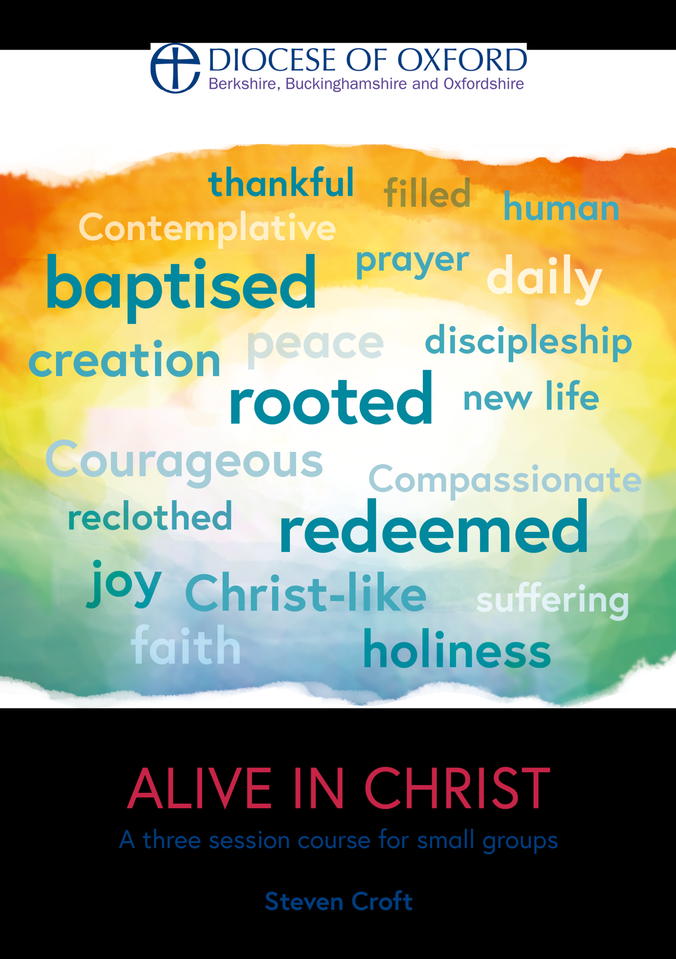
‘HOUSE GROUPS’

Bishop Steven has written this short three session course on the book of Colossians. The booklets will be available in time for Lent and cost £2.50.

GROUP A will be meeting at the vicarage on Tuesdays at 11am. 276A Cowley Rd. Phil Ritchie. Starting on 12th March
GROUP B will be meeting at the home of Janet McCrae at 7.30pm on Wednesday 20th, 27th and 3rd
GROUP C will be meeting at St Alban’s church after the Sunday Eucharist. David Gimson is facilitating this group.

CONFIRMATION CATCH UP! ALL WELCOME
Three follow up sessions after the recent Confirmation at St Albans.
Sundays at 4pm:
10th March, The Church
24th March, The Bible
31st March, The Eucharist and prayer.
All three sessions at St Albans church, Charles Street.
IONA/TAIZE EVENING AT BARTLEMAS CHAPEL
Come and join us on Wednesday 17th April at 7pm for an evening of singing, prayer and silence.

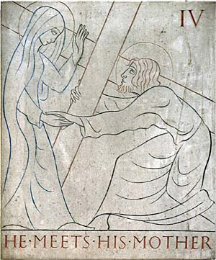
STATIONS OF THE CROSS WITH THE GILL STATIONS

Friday 12 noon, 29th March, 5th April and 12th April. This will last for under an hour. A beautiful way to pray.

STATIONS OF THE CROSS AT ST MARY AND ST JOHN
We will pray three stations during the first half of the Eucharist in Lent on Thursday mornings at 10.30am.

POETRY
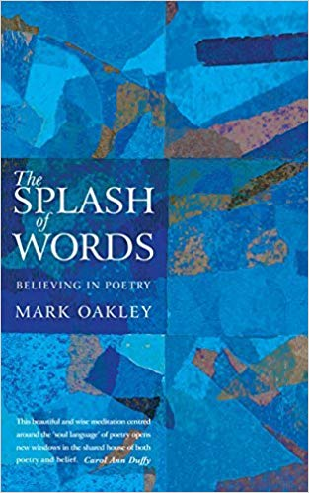
After the 10.30am Thursday morning Eucharist at St Mary and St John we will be choosing a poem from Mark Oakley’s book ‘The Splash of Words’ and discussing it together.

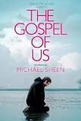
FILM NIGHT AT THE VICARAGE
There will be a film night at the vicarage on Tuesday 2nd April at 7pm. This year the film is Michael Sheen’s The Gospel of Us. The film is a 2012 Welsh drama based on the Owen Sheers novel of the same name and the three-day Passion play that Michael Sheen acted in at his home town of Port Talbot in April 2011

MORNING AND EVENING PRAYER AT SS MARY & JOHN
You are welcome to join us Monday to Friday 8am and 5pm for 20 minutes of prayer (Moring prayer begins at 8.15am after 15 minutes of silent prayer). On Tuesday evenings at 5pm Evening Prayer is combined with a short Eucharist which ends at 5.30pm.

STILLNESS AND SILENCE
Wednesdays in March, 12 noon for an hour in the Bethlehem Chapel. Pop in for a few minutes or stay for the whole hour. All welcome.

INTRODUCTION TO MEDITATION
The Christian Church has a long tradition of meditation. These four sessions offer a practical guide about how to “come home to ourselves" in the here and now, inviting the rhythm of our breathing and awareness of our senses to settle our thoughts and relax our bodies. Please bring 2 cushions. Sessions led by Gentian Rahtz.
We will meet in St Mary and St John Church 12 noon on 13th March, 27th March, 3rd April and 10th April.

HEALING OF BODY AND MIND: CALLING ON THE HOLY SPIRIT AND PRAYER
Erik Keeney and John Hammock are planning two sessions at the Old School on Friday March 29th and Saturday March 30th. Erik has been a monk living and working closely with Father Thomas Keating, who was known as one of the principal developers of Centering Prayer, a contemporary method of contemplative prayer. I have been studying and practicing Healing Qi Gong and adapting it to Christian teachings. Come to either or both.
On Friday evening from 7-9PM we will introduce these two topics and lead the group in initial practice.
On Saturday from 10-4PM we will go deeper with meditation, healing qi gong practice and group practice. For this session we will ask for a donation if at all possible to cover costs.

ENCOUNTERING THE CROSS
An exhibition of art by Nick Mynheer, Roger Wagner, Robert Wright, Romola Parish and Eularia Clarke. 3rd March to 14th April St Giles’ Church, Oxford, OX2 6HT. Weekdays: Noon to 2:00pm Saturdays: 2:00pm to 5:00pm Sundays: Noon to 4:00pm. http://www.st-giles-church.org.
Associated talk : Appreciating the Cross
St Giles’s Church, Oxford April 4th “An artist’s representation of the Cross”. Canon Robert Wright & Fleur Dorrell. The talks are scheduled to be at 12:30pm on the Thursdays of Lent 2019 in St Giles Church

SIGN UP SHEET
Please tick the events/groups you would like to attend, PLEASE RETURN NEXT SUNDAY
NAME …………………………………….
EVENT/GROUP | I WOULD LIKE TO ATTEND
Alive in Christ – Group A
Tuesdays at 11am, 12th March start date
Alive in Christ – Group B
Wednesday 20th, 27th and 3rd
Alive in Christ – Group C
At St Albans following the Sunday morning Service
Confirmation Catch up
Sundays at 4pm 10th,24th and 31st March
Iona/Taize evening at Bartlemas
Wednesday 17th April at 7pm
Film Night at the Vicarage
Tuesday 2nd April at 7pm
Healing on Mind and Body
Friday 29th March, 7-9pm
Healing of Mind and Body
Saturday 30th March, 10-4pm
Introduction to Meditation
12 noon Wednesdays, 4 sessions

Please hand this in at the welcome desk by the door or to Fr Phil

