Thy Kingdom Come
Ascension to Pentecost
31 May–8 June
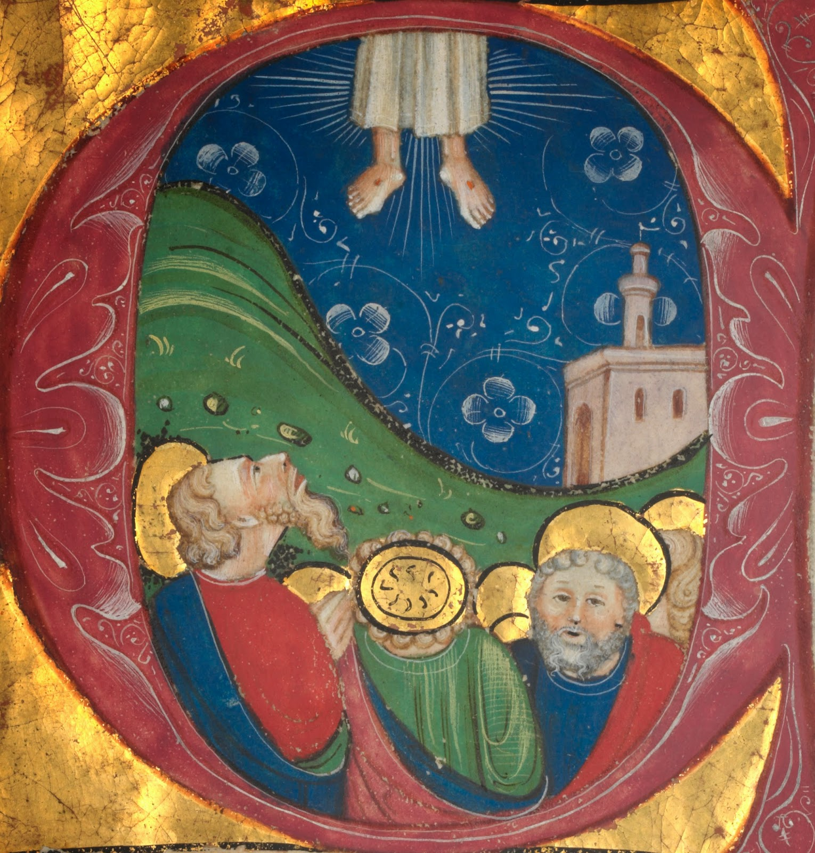

‘So Christ passes on beyond them to take the glory of God at the right hand of God. But there He is not glorified in His own person only. His apostles had fed upon him, had his body within them by virtue of the Holy Eucharist, although they had not yet come to live thereby. He was in them, but they were not yet in Him. Now, upon his Ascension, his body in them is glorified instantaneously with the glorifying of his body at the right hand of God. Like an electric flash the glory of the Spirit shines out in the fires of Pentecost.’
Further Letters of Richard Meaux Benson.
Services

Ascension Day 7.30am – Morning Prayer on the tower
Thursday 30 May followed by breakfast in the Vicarage.

7.30pm – Eucharist at Bartlemas Chapel
followed by a glass of sparkling wine.

Visitation 5.00pm – Eucharist at St Mary and St John
Friday 31 May for the Visitation of the Blessed Virgin Mary

Pentecost 8.00am – Eucharist at St Mary and St John
Sunday 9 June
10.00am – Joint Service at St Mary and St John
with procession form All Saints Sister of the Poor convent, with recommissioning of the south
porch, baptism and a party!

6.15 – Eucharist at St Mary and St John

Corpus Christi 6.30pm – High Mass at St Stephen’s House
Thursday 20 June followed by supper in college (please sign up
in church if you will be attending).

Praying between Ascension Day and Pentecost
Ascension is the day when we remember Jesus’ return to heaven after his resurrection, and Pentecost is when we celebrate the outpouring of the Holy Spirit on Jesus’ disciples—often known as the ‘birthday of the Church’. The nine days between these two key celebrations offer us an opportunity for prayer and reflection as we long for that gift of the Holy Spirit for ourselves and our communities.
In this in-between time, we invite you to pray with us, “Thy Kingdom Come”—that the Holy Spirit will come and bless and challenge us to witness to God’s life-changing work.

Everything you need is in this booklet, and over each of the nine days we are invited to:

WAIT prayerfully for the Holy Spirit. Pause and breathe, creating a space into which God can speak.

READ the Bible texts set for the day, allow them to enliven your heart, stir your soul and spark your imagination.

LISTEN for insight through idea or image, through recollection or curiosity. Let that Word dwell within you, as you listen for yourself and your community.

RESPOND to the prompting of the Word, with an action that leads to life-giving change.

Then, use the words of the collect below to gather up and bless these moments of prayerful waiting upon God, so that his kingdom might be seen more fully in you.

The Daily Collect

O God the King of glory,
you have exalted your only Son Jesus Christ
with great triumph to your kingdom in heaven:
we beseech you, leave us not comfortless,
but send your Holy Spirit to strengthen us
and exalt us to the place where our Saviour Christ is gone before,
who is alive and reigns with you,
in the unity of the Holy Spirit,
one God, now and for ever.
Amen.

Day One Visitation of the Blessed Virgin Mary Friday 31 May

Hannah’s Prayer (1 Samuel 2.1–10)

Hannah prayed and said,
‘My heart exults in the Lord;
my strength is exalted in my God.
My mouth derides my enemies,
because I rejoice in my victory.
There is no Holy One like the Lord,
no one besides you;
there is no Rock like our God.
Talk no more so very proudly,
let not arrogance come from your mouth;
for the Lord is a God of knowledge,
and by him actions are weighed.
The bows of the mighty are broken,
but the feeble gird on strength.
Those who were full have hired themselves out for bread,
but those who were hungry are fat with spoil.
The barren has borne seven,
but she who has many children is forlorn.
The Lord kills and brings to life;
he brings down to Sheol and raises up.
The Lord makes poor and makes rich;
he brings low, he also exalts.
He raises up the poor from the dust;
he lifts the needy from the ash heap,
to make them sit with princes
and inherit a seat of honour.
For the pillars of the earth are the Lord’s,
and on them he has set the world.
He will guard the feet of his faithful ones,
but the wicked shall be cut off in darkness;
for not by might does one prevail.
The Lord! His adversaries shall be shattered;
the Most High will thunder in heaven.
The Lord will judge the ends of the earth;
he will give strength to his king,
and exalt the power of his anointed.’

The True Kindred of Jesus (Mark 3.31–end)

Then his mother and his brothers came; and standing outside, they sent to him and called him. A crowd was sitting around him; and they said to him, ‘Your mother and your brothers and sisters are outside, asking for you.’ And he replied, ‘Who are my mother and my brothers?’ And looking at those who sat around him, he said, ‘Here are my mother and my brothers! Whoever does the will of God is my brother and sister and mother.’

The Visitation, by Malcolm Guite

Here is a meeting made of hidden joys
Of lightenings cloistered in a narrow place
From quiet hearts the sudden flame of praise
And in the womb the quickening kick of grace.
Two women on the very edge of things
Unnoticed and unknown to men of power
But in their flesh the hidden Spirit sings
And in their lives the buds of blessing flower.
And Mary stands with all we call ‘too young’,
Elizabeth with all called ‘past their prime’
They sing today for all the great unsung
Women who turned eternity to time
Favoured of heaven, outcast on the earth
Prophets who bring the best in us to birth.

Day Two Saturday 1 June

The Seventy Elders (Numbers 11.16–17, 24–29)

So the Lord said to Moses, ‘Gather for me seventy of the elders of Israel, whom you know to be the elders of the people and officers over them; bring them to the tent of meeting, and have them take their place there with you. I will come down and talk with you there; and I will take some of the spirit that is on you and put it on them; and they shall bear the burden of the people along with you so that you will not bear it all by yourself.
So Moses went out and told the people the words of the Lord; and he gathered seventy elders of the people, and placed them all around the tent. Then the Lord came down in the cloud and spoke to him, and took some of the spirit that was on him and put it on the seventy elders; and when the spirit rested upon them, they prophesied. But they did not do so again.
Two men remained in the camp, one named Eldad, and the other named Medad, and the spirit rested on them; they were among those registered, but they had not gone out to the tent, and so they prophesied in the camp. And a young man ran and told Moses, ‘Eldad and Medad are prophesying in the camp.’ And Joshua son of Nun, the assistant of Moses, one of his chosen men, said, ‘My lord Moses, stop them!’ But Moses said to him, ‘Are you jealous for my sake? Would that all the Lord’s people were prophets, and that the Lord would put his spirit on them!’

Proclaiming Christ Crucified (1 Corinthians 2)

When I came to you, brothers and sisters, I did not come proclaiming the mystery of God to you in lofty words or wisdom. For I decided to know nothing among you except Jesus Christ, and him crucified. And I came to you in weakness and in fear and in much trembling. My speech and my proclamation were not with plausible words of wisdom, but with a demonstration of the Spirit and of power, so that your faith might rest not on human wisdom but on the power of God.
Yet among the mature we do speak wisdom, though it is not a wisdom of this age or of the rulers of this age, who are doomed to perish. But we speak God’s wisdom, secret and hidden, which God decreed before the ages for our glory. None of the rulers of this age understood this; for if they had, they would not have crucified the Lord of glory. But, as it is written,
‘What no eye has seen, nor ear heard,
nor the human heart conceived,
what God has prepared for those who love him’—
these things God has revealed to us through the Spirit; for the Spirit searches everything, even the depths of God. For what human being knows what is truly human except the human spirit that is within? So also no one comprehends what is truly God’s except the Spirit of God. Now we have received not the spirit of the world, but the Spirit that is from God, so that we may understand the gifts bestowed on us by God. And we speak of these things in words not taught by human wisdom but taught by the Spirit, interpreting spiritual things to those who are spiritual.
Those who are unspiritual do not receive the gifts of God’s Spirit, for they are foolishness to them, and they are unable to understand them because they are discerned spiritually. Those who are spiritual discern all things, and they are themselves subject to no one else’s scrutiny.
‘For who has known the mind of the Lord
so as to instruct him?’
But we have the mind of Christ.

Day Three Sunday 2 June

Moses Dies and Is Buried in the Land of Moab (Deuteronomy 34)
Then Moses went up from the plains of Moab to Mount Nebo, to the top of Pisgah, which is opposite Jericho, and the Lord showed him the whole land: Gilead as far as Dan, all Naphtali, the land of Ephraim and Manasseh, all the land of Judah as far as the Western Sea, the Negeb, and the Plain—that is, the valley of Jericho, the city of palm trees—as far as Zoar. The Lord said to him, ‘This is the land of which I swore to Abraham, to Isaac, and to Jacob, saying, “I will give it to your descendants”; I have let you see it with your eyes, but you shall not cross over there.’ Then Moses, the servant of the Lord, died there in the land of Moab, at the Lord’s command. He was buried in a valley in the land of Moab, opposite Beth-peor, but no one knows his burial place to this day. Moses was one hundred and twenty years old when he died; his sight was unimpaired and his vigour had not abated. The Israelites wept for Moses in the plains of Moab for thirty days; then the period of mourning for Moses was ended.
Joshua son of Nun was full of the spirit of wisdom, because Moses had laid his hands on him; and the Israelites obeyed him, doing as the Lord had commanded Moses.
Never since has there arisen a prophet in Israel like Moses, whom the Lord knew face to face. He was unequalled for all the signs and wonders that the Lord sent him to perform in the land of Egypt, against Pharaoh and all his servants and his entire land, and for all the mighty deeds and all the terrifying displays of power that Moses performed in the sight of all Israel.

The Ascension of Jesus (Luke 24.44–end)

Then he said to them, ‘These are my words that I spoke to you while I was still with you—that everything written about me in the law of Moses, the prophets, and the psalms must be fulfilled.’ Then he opened their minds to understand the scriptures, and he said to them, ‘Thus it is written, that the Messiah is to suffer and to rise from the dead on the third day, and that repentance and forgiveness of sins is to be proclaimed in his name to all nations, beginning from Jerusalem. You are witnesses of these things. And see, I am sending upon you what my Father promised; so stay here in the city until you have been clothed with power from on high.’
Then he led them out as far as Bethany, and, lifting up his hands, he blessed them. While he was blessing them, he withdrew from them and was carried up into heaven. And they worshipped him, and returned to Jerusalem with great joy; and they were continually in the temple blessing God.

From Ascension Thursday, by Saunders Lewis

What's on this May morning in the hills?
Look at them, at the gold of the broom and laburnum
And the bright surplice on the shoulders of the thorn
And the intent emerald of the grass and the still calves;

See the candlestick of the chestnut tree alight,
The groves kneeling and the mute birch a nun,
The cuckoo's two-notes over the shining hush of the brook
And the form of the mist bending from the censer of the meadows;

Come out, you men, from the council houses before
The rabbits scamper, come with the weasel to see
The elevation of the unblemished host
And the Father kissing the Son in the white dew.

Day Four Monday 3 June

Joshua appointed Moses’ Successor (Numbers 27.15–end)

Moses spoke to the Lord, saying, ‘Let the Lord, the God of the spirits of all flesh, appoint someone over the congregation who shall go out before them and come in before them, who shall lead them out and bring them in, so that the congregation of the Lord may not be like sheep without a shepherd.’ So the Lord said to Moses, ‘Take Joshua son of Nun, a man in whom is the spirit, and lay your hand upon him; have him stand before Eleazar the priest and all the congregation, and commission him in their sight. You shall give him some of your authority, so that all the congregation of the Israelites may obey. But he shall stand before Eleazar the priest, who shall inquire for him by the decision of the Urim before the Lord; at his word they shall go out, and at his word they shall come in, both he and all the Israelites with him, the whole congregation.’ So Moses did as the Lord commanded him. He took Joshua and had him stand before Eleazar the priest and the whole congregation; he laid his hands on him and commissioned him—as the Lord had directed through Moses.

On Divisions in the Corinthian Church (1 Corinthians 3)

And so, brothers and sisters, I could not speak to you as spiritual people, but rather as people of the flesh, as infants in Christ. I fed you with milk, not solid food, for you were not ready for solid food. Even now you are still not ready, for you are still of the flesh. For as long as there is jealousy and quarrelling among you, are you not of the flesh, and behaving according to human inclinations? For when one says, ‘I belong to Paul’, and another, ‘I belong to Apollos’, are you not merely human?
What then is Apollos? What is Paul? Servants through whom you came to believe, as the Lord assigned to each. I planted, Apollos watered, but God gave the growth. So neither the one who plants nor the one who waters is anything, but only God who gives the growth. The one who plants and the one who waters have a common purpose, and each will receive wages according to the labour of each. For we are God’s servants, working together; you are God’s field, God’s building.
According to the grace of God given to me, like a skilled master builder I laid a foundation, and someone else is building on it. Each builder must choose with care how to build on it. For no one can lay any foundation other than the one that has been laid; that foundation is Jesus Christ. Now if anyone builds on the foundation with gold, silver, precious stones, wood, hay, straw—the work of each builder will become visible, for the Day will disclose it, because it will be revealed with fire, and the fire will test what sort of work each has done. If what has been built on the foundation survives, the builder will receive a reward. If the work is burned, the builder will suffer loss; the builder will be saved, but only as through fire.
Do you not know that you are God’s temple and that God’s Spirit dwells in you? If anyone destroys God’s temple, God will destroy that person. For God’s temple is holy, and you are that temple.
Do not deceive yourselves. If you think that you are wise in this age, you should become fools so that you may become wise. For the wisdom of this world is foolishness with God. For it is written,
‘He catches the wise in their craftiness’,
and again,
‘The Lord knows the thoughts of the wise,
that they are futile.’
So let no one boast about human leaders. For all things are yours, whether Paul or Apollos or Cephas or the world or life or death or the present or the future—all belong to you, and you belong to Christ, and Christ belongs to God.

Day Five Tuesday 4 June

Samuel anoints Saul (1 Samuel 10.1–10)

Samuel took a phial of oil and poured it on his head, and kissed him; he said, ‘The Lord has anointed you ruler over his people Israel. You shall reign over the people of the Lord and you will save them from the hand of their enemies all around. Now this shall be the sign to you that the Lord has anointed you ruler over his heritage: When you depart from me today you will meet two men by Rachel’s tomb in the territory of Benjamin at Zelzah; they will say to you, “The donkeys that you went to seek are found, and now your father has stopped worrying about them and is worrying about you, saying: What shall I do about my son?” Then you shall go on from there further and come to the oak of Tabor; three men going up to God at Bethel will meet you there, one carrying three kids, another carrying three loaves of bread, and another carrying a skin of wine. They will greet you and give you two loaves of bread, which you shall accept from them. After that you shall come to Gibeath-elohim, at the place where the Philistine garrison is; there, as you come to the town, you will meet a band of prophets coming down from the shrine with harp, tambourine, flute, and lyre playing in front of them; they will be in a prophetic frenzy. Then the spirit of the Lord will possess you, and you will be in a prophetic frenzy along with them and be turned into a different person. Now when these signs meet you, do whatever you see fit to do, for God is with you. And you shall go down to Gilgal ahead of me; then I will come down to you to present burnt-offerings and offer sacrifices of well-being. For seven days you shall wait, until I come to you and show you what you shall do.’
As he turned away to leave Samuel, God gave him another heart; and all these signs were fulfilled that day. When they were going from there to Gibeah, a band of prophets met him; and the spirit of God possessed him, and he fell into a prophetic frenzy along with them.

Spiritual Gifts (1 Corinthians 12.1–13)
Now concerning spiritual gifts, brothers and sisters, I do not want you to be uninformed. You know that when you were pagans, you were enticed and led astray to idols that could not speak. Therefore I want you to understand that no one speaking by the Spirit of God ever says ‘Let Jesus be cursed!’ and no one can say ‘Jesus is Lord’ except by the Holy Spirit.
Now there are varieties of gifts, but the same Spirit; and there are varieties of services, but the same Lord; and there are varieties of activities, but it is the same God who activates all of them in everyone. To each is given the manifestation of the Spirit for the common good. To one is given through the Spirit the utterance of wisdom, and to another the utterance of knowledge according to the same Spirit, to another faith by the same Spirit, to another gifts of healing by the one Spirit, to another the working of miracles, to another prophecy, to another the discernment of spirits, to another various kinds of tongues, to another the interpretation of tongues. All these are activated by one and the same Spirit, who allots to each one individually just as the Spirit chooses.
For just as the body is one and has many members, and all the members of the body, though many, are one body, so it is with Christ. For in the one Spirit we were all baptized into one body—Jews or Greeks, slaves or free—and we were all made to drink of one Spirit.
Day Six Wednesday 5 June

Elijah flees from Jezebel (1 Kings 19.1–18)

Ahab told Jezebel all that Elijah had done, and how he had killed all the prophets with the sword. Then Jezebel sent a messenger to Elijah, saying, ‘So may the gods do to me, and more also, if I do not make your life like the life of one of them by this time tomorrow.’ Then he was afraid; he got up and fled for his life, and came to Beer-sheba, which belongs to Judah; he left his servant there.
But he himself went a day’s journey into the wilderness, and came and sat down under a solitary broom tree. He asked that he might die: ‘It is enough; now, O Lord, take away my life, for I am no better than my ancestors.’ Then he lay down under the broom tree and fell asleep. Suddenly an angel touched him and said to him, ‘Get up and eat.’ He looked, and there at his head was a cake baked on hot stones, and a jar of water. He ate and drank, and lay down again. The angel of the Lord came a second time, touched him, and said, ‘Get up and eat, otherwise the journey will be too much for you.’ He got up, and ate and drank; then he went in the strength of that food for forty days and forty nights to Horeb the mount of God. At that place he came to a cave, and spent the night there.
Then the word of the Lord came to him, saying, ‘What are you doing here, Elijah?’ He answered, ‘I have been very zealous for the Lord, the God of hosts; for the Israelites have forsaken your covenant, thrown down your altars, and killed your prophets with the sword. I alone am left, and they are seeking my life, to take it away.’
He said, ‘Go out and stand on the mountain before the Lord, for the Lord is about to pass by.’ Now there was a great wind, so strong that it was splitting mountains and breaking rocks in pieces before the Lord, but the Lord was not in the wind; and after the wind an earthquake, but the Lord was not in the earthquake; and after the earthquake a fire, but the Lord was not in the fire; and after the fire a sound of sheer silence. When Elijah heard it, he wrapped his face in his mantle and went out and stood at the entrance of the cave. Then there came a voice to him that said, ‘What are you doing here, Elijah?’ He answered, ‘I have been very zealous for the Lord, the God of hosts; for the Israelites have forsaken your covenant, thrown down your altars, and killed your prophets with the sword. I alone am left, and they are seeking my life, to take it away.’ Then the Lord said to him, ‘Go, return on your way to the wilderness of Damascus; when you arrive, you shall anoint Hazael as king over Aram. Also you shall anoint Jehu son of Nimshi as king over Israel; and you shall anoint Elisha son of Shaphat of Abel-meholah as prophet in your place. Whoever escapes from the sword of Hazael, Jehu shall kill; and whoever escapes from the sword of Jehu, Elisha shall kill. Yet I will leave seven thousand in Israel, all the knees that have not bowed to Baal, and every mouth that has not kissed him.’

The Baptism of Jesus (Matthew 3.13–end)

Then Jesus came from Galilee to John at the Jordan, to be baptized by him. John would have prevented him, saying, ‘I need to be baptized by you, and do you come to me?’ But Jesus answered him, ‘Let it be so now; for it is proper for us in this way to fulfil all righteousness.’ Then he consented. And when Jesus had been baptized, just as he came up from the water, suddenly the heavens were opened to him and he saw the Spirit of God descending like a dove and alighting on him. And a voice from heaven said, ‘This is my Son, the Beloved, with whom I am well pleased.’

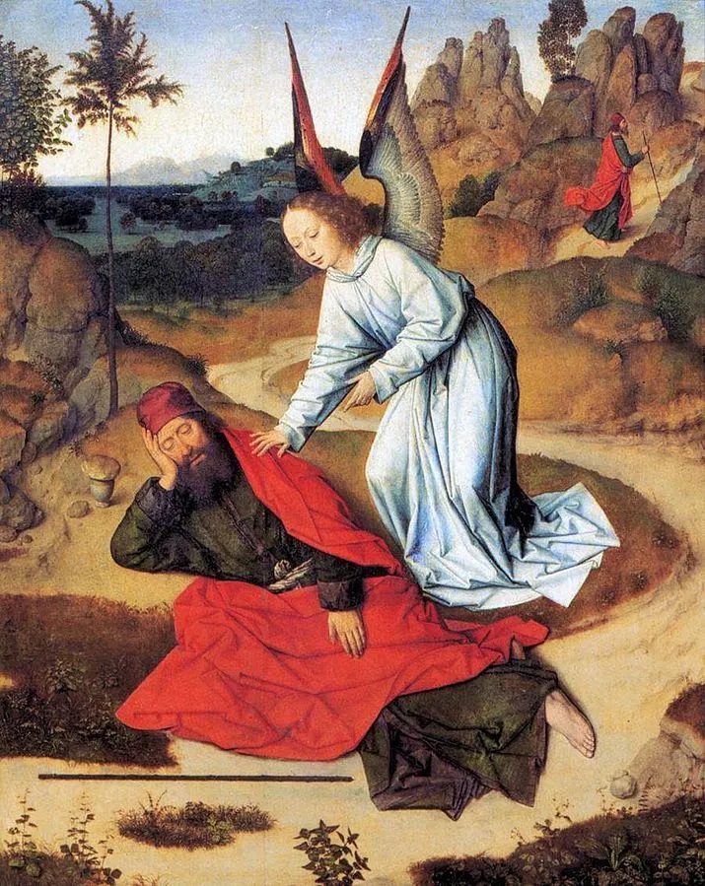

Prophet Elijah in the Desert, by Dieric Bouts, 1464

Day Seven Thursday 6 June

God will restore Israel (Ezekiel 11.14-20)

Then the word of the Lord came to me: Mortal, your kinsfolk, your own kin, your fellow exiles, the whole house of Israel, all of them, are those of whom the inhabitants of Jerusalem have said, ‘They have gone far from the Lord; to us this land is given for a possession.’ Therefore say: Thus says the Lord God: Though I removed them far away among the nations, and though I scattered them among the countries, yet I have been a sanctuary to them for a little while in the countries where they have gone. Therefore say: Thus says the Lord God: I will gather you from the peoples, and assemble you out of the countries where you have been scattered, and I will give you the land of Israel. When they come there, they will remove from it all its detestable things and all its abominations. I will give them one heart, and put a new spirit within them; I will remove the heart of stone from their flesh and give them a heart of flesh, so that they may follow my statutes and keep my ordinances and obey them. Then they shall be my people, and I will be their God.

The Harvest Is Great, the Labourers Few (Matthew 9.35–10.20)

Then Jesus went about all the cities and villages, teaching in their synagogues, and proclaiming the good news of the kingdom, and curing every disease and every sickness. When he saw the crowds, he had compassion for them, because they were harassed and helpless, like sheep without a shepherd. Then he said to his disciples, ‘The harvest is plentiful, but the labourers are few; therefore ask the Lord of the harvest to send out labourers into his harvest.’
Then Jesus summoned his twelve disciples and gave them authority over unclean spirits, to cast them out, and to cure every disease and every sickness. These are the names of the twelve apostles: first, Simon, also known as Peter, and his brother Andrew; James son of Zebedee, and his brother John; Philip and Bartholomew; Thomas and Matthew the tax-collector; James son of Alphaeus, and Thaddaeus; Simon the Cananaean, and Judas Iscariot, the one who betrayed him.
These twelve Jesus sent out with the following instructions: ‘Go nowhere among the Gentiles, and enter no town of the Samaritans, but go rather to the lost sheep of the house of Israel. As you go, proclaim the good news, “The kingdom of heaven has come near.” Cure the sick, raise the dead, cleanse the lepers, cast out demons. You received without payment; give without payment. Take no gold, or silver, or copper in your belts, no bag for your journey, or two tunics, or sandals, or a staff; for labourers deserve their food. Whatever town or village you enter, find out who in it is worthy, and stay there until you leave. As you enter the house, greet it. If the house is worthy, let your peace come upon it; but if it is not worthy, let your peace return to you. If anyone will not welcome you or listen to your words, shake off the dust from your feet as you leave that house or town. Truly I tell you, it will be more tolerable for the land of Sodom and Gomorrah on the day of judgement than for that town.
‘See, I am sending you out like sheep into the midst of wolves; so be wise as serpents and innocent as doves. Beware of them, for they will hand you over to councils and flog you in their synagogues; and you will be dragged before governors and kings because of me, as a testimony to them and the Gentiles. When they hand you over, do not worry about how you are to speak or what you are to say; for what you are to say will be given to you at that time; for it is not you who speak, but the Spirit of your Father speaking through you.
Day Eight Friday 7 June

The Renewal of Israel (Ezekiel 36.22–28)

Therefore say to the house of Israel, Thus says the Lord God: It is not for your sake, O house of Israel, that I am about to act, but for the sake of my holy name, which you have profaned among the nations to which you came. I will sanctify my great name, which has been profaned among the nations, and which you have profaned among them; and the nations shall know that I am the Lord, says the Lord God, when through you I display my holiness before their eyes. I will take you from the nations, and gather you from all the countries, and bring you into your own land. I will sprinkle clean water upon you, and you shall be clean from all your uncleannesses, and from all your idols I will cleanse you. A new heart I will give you, and a new spirit I will put within you; and I will remove from your body the heart of stone and give you a heart of flesh. I will put my spirit within you, and make you follow my statutes and be careful to observe my ordinances. Then you shall live in the land that I gave to your ancestors; and you shall be my people, and I will be your God.

Jesus and Beelzebul (Matthew 12.22–32)

Then they brought to him a demoniac who was blind and mute; and he cured him, so that the one who had been mute could speak and see. All the crowds were amazed and said, ‘Can this be the Son of David?’ But when the Pharisees heard it, they said, ‘It is only by Beelzebul, the ruler of the demons, that this fellow casts out the demons.’ He knew what they were thinking and said to them, ‘Every kingdom divided against itself is laid waste, and no city or house divided against itself will stand. If Satan casts out Satan, he is divided against himself; how then will his kingdom stand? If I cast out demons by Beelzebul, by whom do your own exorcists cast them out? Therefore they will be your judges. But if it is by the Spirit of God that I cast out demons, then the kingdom of God has come to you. Or how can one enter a strong man’s house and plunder his property, without first tying up the strong man? Then indeed the house can be plundered. Whoever is not with me is against me, and whoever does not gather with me scatters. Therefore I tell you, people will be forgiven for every sin and blasphemy, but blasphemy against the Spirit will not be forgiven. Whoever speaks a word against the Son of Man will be forgiven, but whoever speaks against the Holy Spirit will not be forgiven, either in this age or in the age to come.

Day Nine Saturday 8 June

Wicked Rulers and Prophets (Micah 3.1–8)

And I said:
Listen, you heads of Jacob
and rulers of the house of Israel!
Should you not know justice?—
you who hate the good and love the evil,
who tear the skin off my people,
and the flesh off their bones;
who eat the flesh of my people,
flay their skin off them,
break their bones in pieces,
and chop them up like meat in a kettle,
like flesh in a cauldron.

Then they will cry to the Lord,
but he will not answer them;
he will hide his face from them at that time,
because they have acted wickedly.
Thus says the Lord concerning the prophets
who lead my people astray,
who cry ‘Peace’
when they have something to eat,
but declare war against those
who put nothing into their mouths.
Therefore it shall be night to you, without vision,
and darkness to you, without revelation.
The sun shall go down upon the prophets,
and the day shall be black over them;
the seers shall be disgraced,
and the diviners put to shame;
they shall all cover their lips,
for there is no answer from God.
But as for me, I am filled with power,
with the spirit of the Lord,
and with justice and might,
to declare to Jacob his transgression
and to Israel his sin.

The Whole Armour of God (Ephesians 6.10–20)

Finally, be strong in the Lord and in the strength of his power. Put on the whole armour of God, so that you may be able to stand against the wiles of the devil. For our struggle is not against enemies of blood and flesh, but against the rulers, against the authorities, against the cosmic powers of this present darkness, against the spiritual forces of evil in the heavenly places. Therefore take up the whole armour of God, so that you may be able to withstand on that evil day, and having done everything, to stand firm. Stand therefore, and fasten the belt of truth around your waist, and put on the breastplate of righteousness. As shoes for your feet put on whatever will make you ready to proclaim the gospel of peace. With all of these, take the shield of faith, with which you will be able to quench all the flaming arrows of the evil one. Take the helmet of salvation, and the sword of the Spirit, which is the word of God.
Pray in the Spirit at all times in every prayer and supplication. To that end keep alert and always persevere in supplication for all the saints. Pray also for me, so that when I speak, a message may be given to me to make known with boldness the mystery of the gospel, for which I am an ambassador in chains. Pray that I may declare it boldly, as I must speak.

